Office of the State Inspector General
Policy and Procedure

Subject

CODE OF ETHICS
Supersedes
September 24, 2014
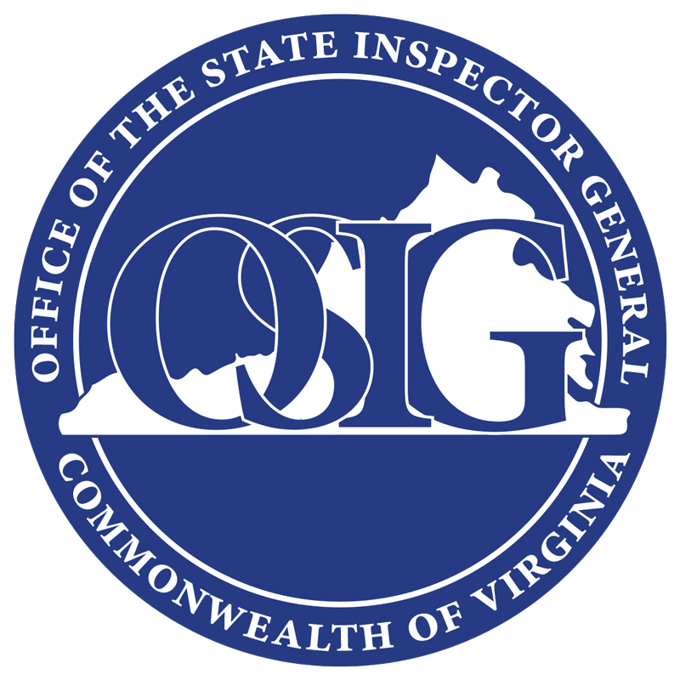
Number
121
Effective Date
September 24, 2015

Authority

Code of Virginia § 2.2-309 et seq.

FOIA Exempt

Attachments
Yes No

Yes No

Purpose
This policy delineates the code of ethics for employees of the Office of the State Inspector General (OSIG).

Scope
All OSIG employees: classified, hourly, contracted, and interns l

Policy
As an employee of the Commonwealth of Virginia (COV) and OSIG, staff agree to adhere to the following when acting within the scope of his or her employment:
- Exhibit the highest level of independence and integrity in the performance of all duties.
- Demonstrate a commitment to professionalism and diligence in the performance of all duties.
- Commit to be a responsible steward of public resources.
- Comply with all applicable state and federal regulations.
- Maintain appropriate confidentiality of sensitive information and records obtained by OSIG.
- Dedicate efforts toward earning the respect, trust, and confidence of the citizens of the Commonwealth.

Review Date
This procedure shall be reviewed annually and updated no later than September 24, 2016.

Signature copy on file

June W. Jennings
State Inspector General

